

**Assignment on Pseudo Code & Flow Chart**

Course Name: Structure Programing

Course code: CIS-115

**Submitted by**

Nabila Sarkar

ID:222-16-675

Section:A

Department of CIS, DIU

**Submitted to**

Abdullah Bin Kasem Bhuiyan

Faculty of Science and Information Technology

Daffodil International University

Contents

Lab task -1(Pseudo code) 2

Simple Condition or Decision making Practice 15

Complex Condition Decision Making Practice 24

# Lab task -1(Pseudo code)

**1)Calculation Niloy’s basic salary:**

1.Declare variable (basic salary) to store fractional value.

2. Show message to enter a basic salary

3.Taking input to variable (basic salary)

4.Calculation,

Dearness allowance =(40*basic salary)/100%

House rent =(20*basic salary)/100%

Gross salary = basic salary+ dearness salary+ house rent.

5.Print output gross salary.

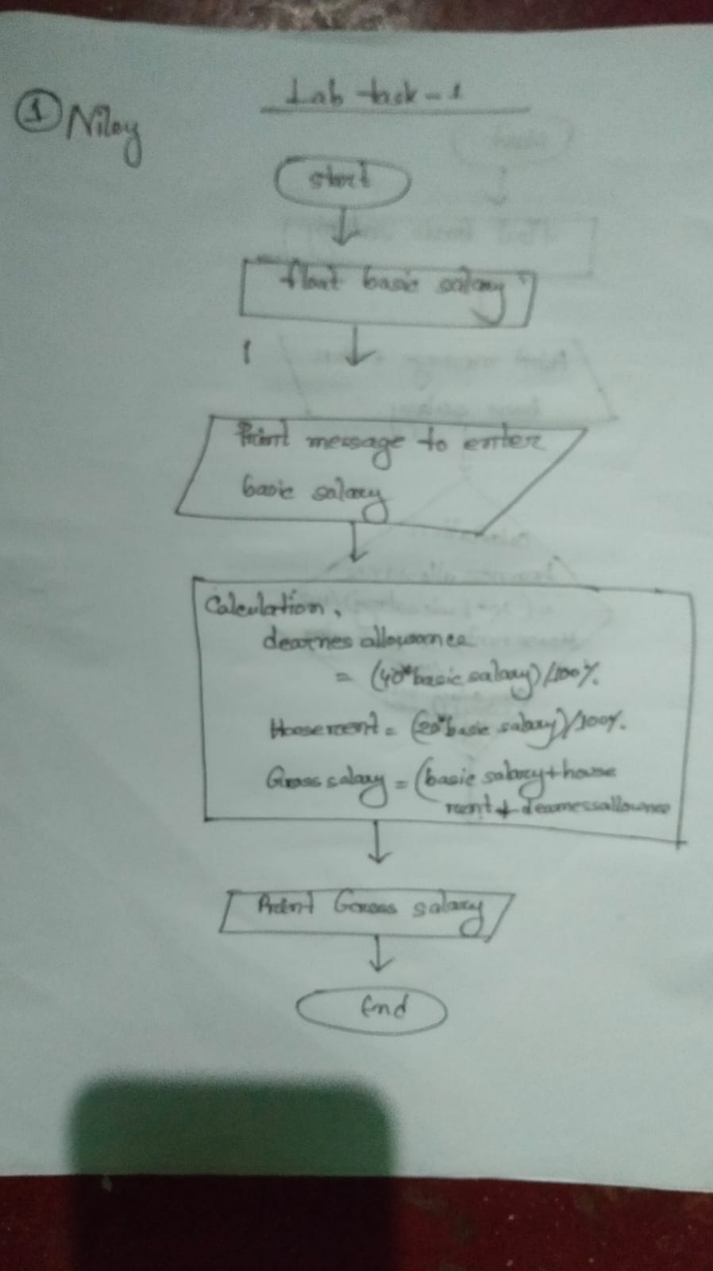6.end

**2)The distance between Mirpur to Ashulia:**

1.Declare variable (distance) to store fractional value.

2. Show message to enter ( distance )

3.Taking input to variable

4.Calculation, meter=1000*distance

feet=3280.84*distance

inches=39370.1*distance

centimeters=100000*distance

5.print output meter

6. print output feet

7. print output inches

8. print output centimeters

9. end

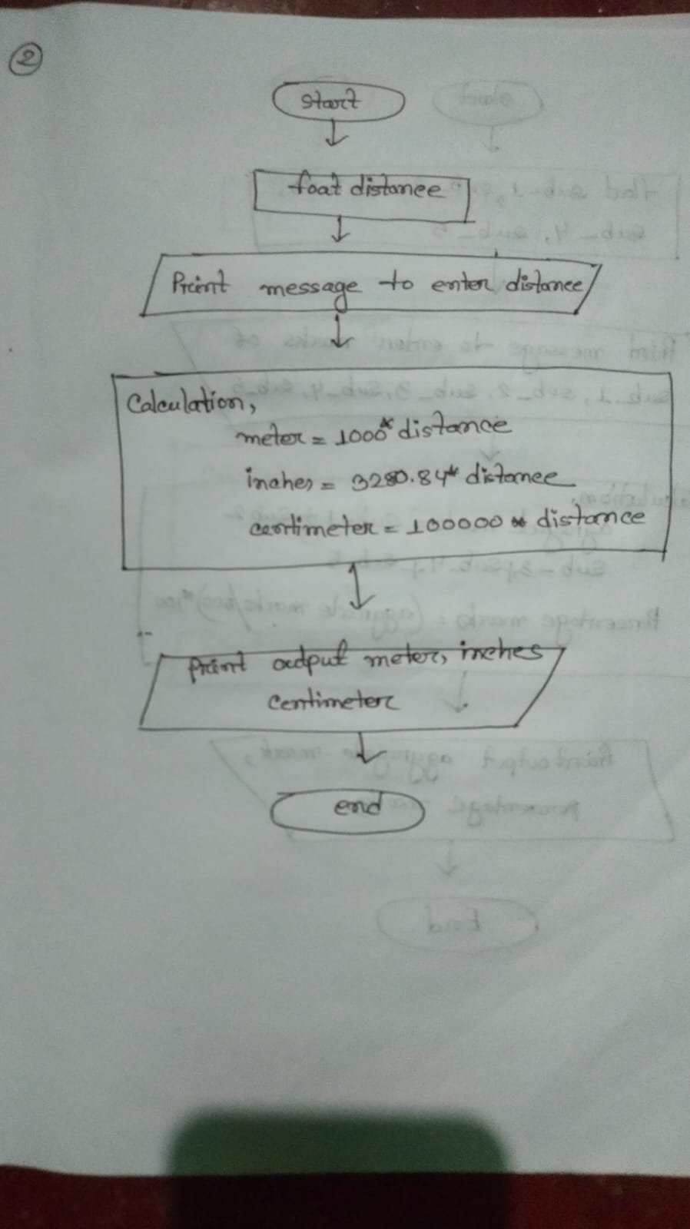

**3)The aggregate marks and percentage marke obtained by one student.**

1.Declare variable( sub_1,sub_2,sub_3,sub_4,sub_5,aggregate_marks,percentage_marks) to storage fractional values.

2. Show message to enter the marks of (sub_1_sub_2,sub_3,sub_4,sub_5,aggregate_marks,percentage_marks)

3.Taking input to variable(sub_1, sub_2,sub_3,sub_4,sub_5,aggregate_marks,percentage_marks)

4.Calculation

aggregate_marks=sub_1+sub_2+sub_3+sub_4+sub_5

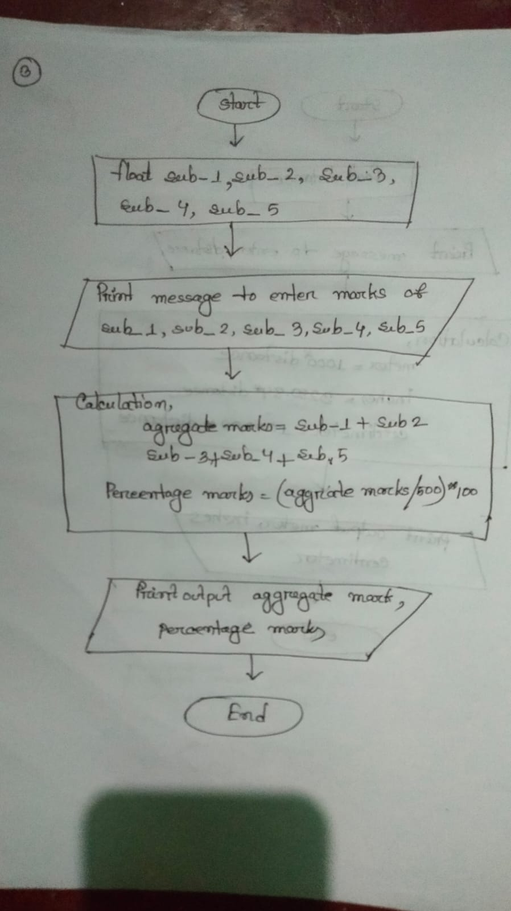percentage_marks=(aggregate_marks/500)*100);

5.Print output aggregate marks

Print output presents marks

6.end.

**4) this is Pseudo Code convert this temperature into centigrade degrees**

1.Declare variable( CityTemperature) to storage fractional value.

2. Show message to enter (city temperature )

3.Taking input to variable

4.Calculation,

centigrade=(citytemperature_F-32)/9*5

5.Print outout temperature into centigrade

6.end

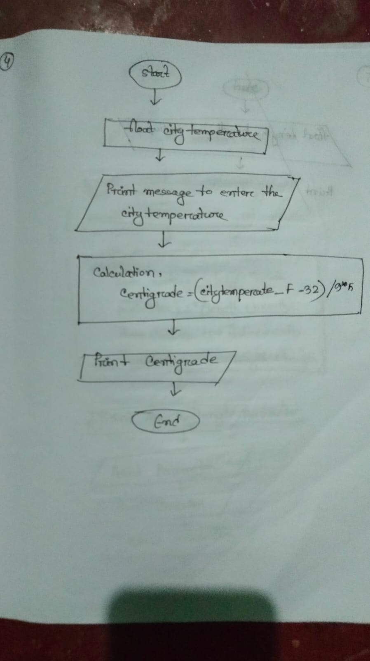

**5) Calculating the area and perimeter of the rectangle , and circumference of the circle.**

1. Declare variable ( length, breadth and radius)to store fractional value.

2. Display the message to enter ( length, breadth and radius )

3.Taking input to variable

4.Calculation,

area rectangle= length*breadth

perimeter=2*(length+breadth)

Area Circule = PI *radius *radius

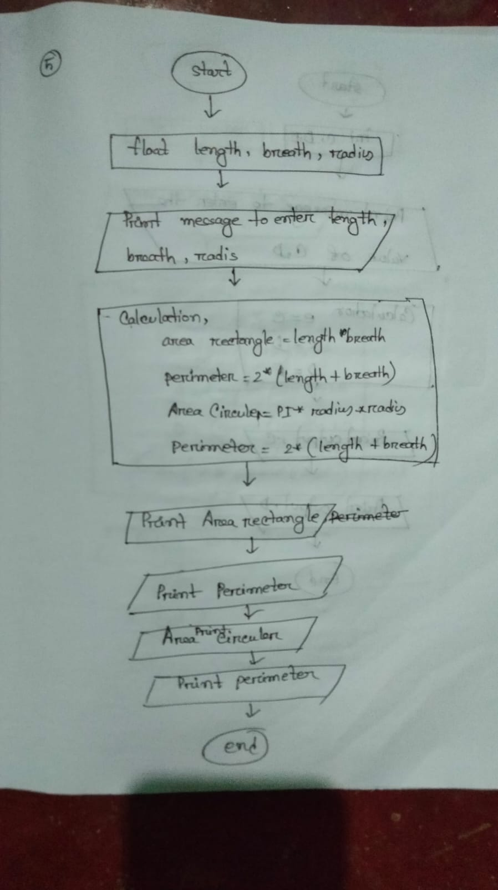circumfere=2*(length+breath)

5. print output Area rectangle

6. print output perimeter

7 print output area circular

8. print output circumfere

9.end

**6)If a 5 digit number is input through the keyboard into the locations C and D.Write a program to interchange the contents of C & D**.

1. Declare variable (C, D,E) to store integer value.

2. Display the message to enter (C ,D)

3.Taking input to variable

4.Calculation, e = c

C = d

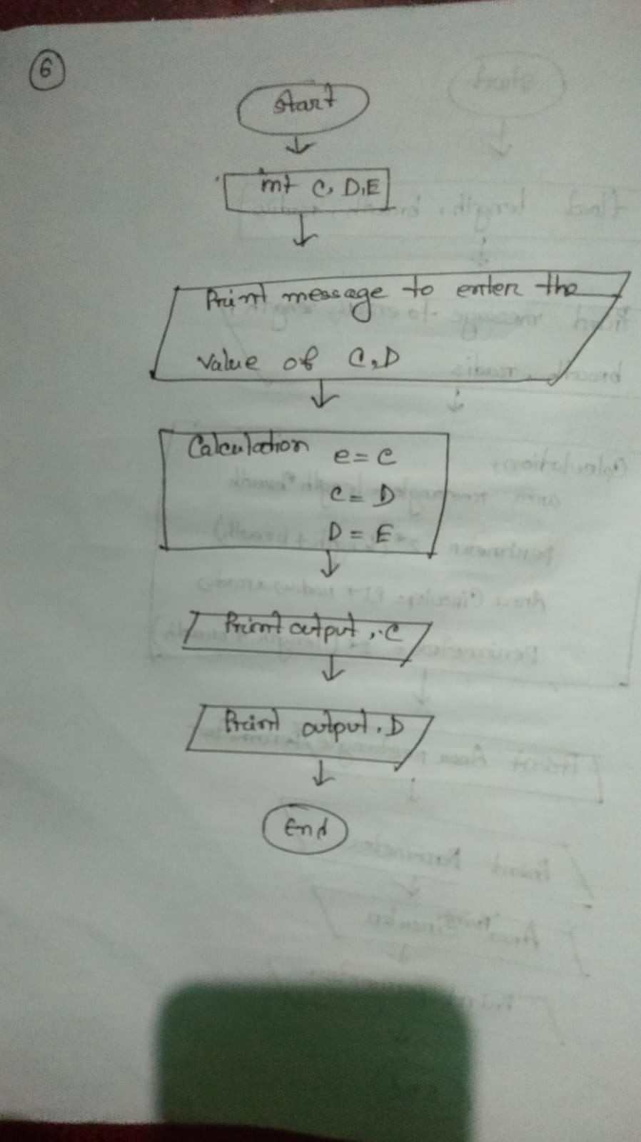 d = e

5.Print output , c

6. Print output , d

7.end

**7)Calculating the sum of five digite number.**

1. Declare variabl(number) to store integerl value.

2. Display the message to enter ( number )

3.Taking input to variable

4.Calculation, e=num%10;

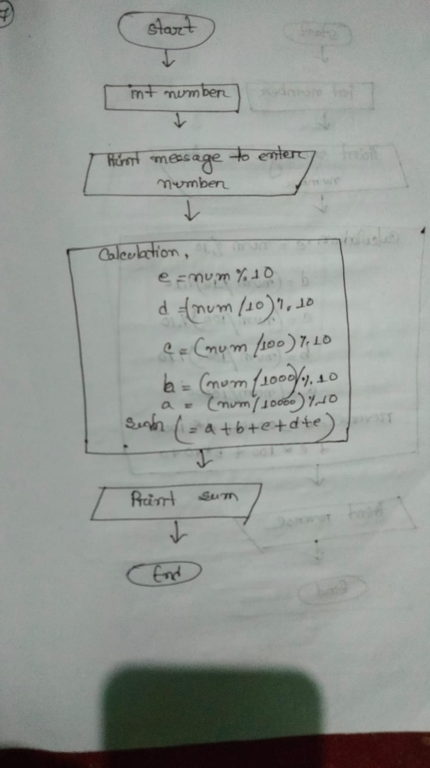 d=(num/10)%10;

c=(num/100)%10;

b=(num/1000)%10;

a=(num/10000);

sum = a+b+c+d+e

5.Print output sum

6.end

**8)Reversing any 5 digite number**

1. Declare variabl(number) to store fractional value.

2. Display the message to enter ( number )

3.Taking input to variable

4.Calculation, e=num%10;

d=(num/10)%10;

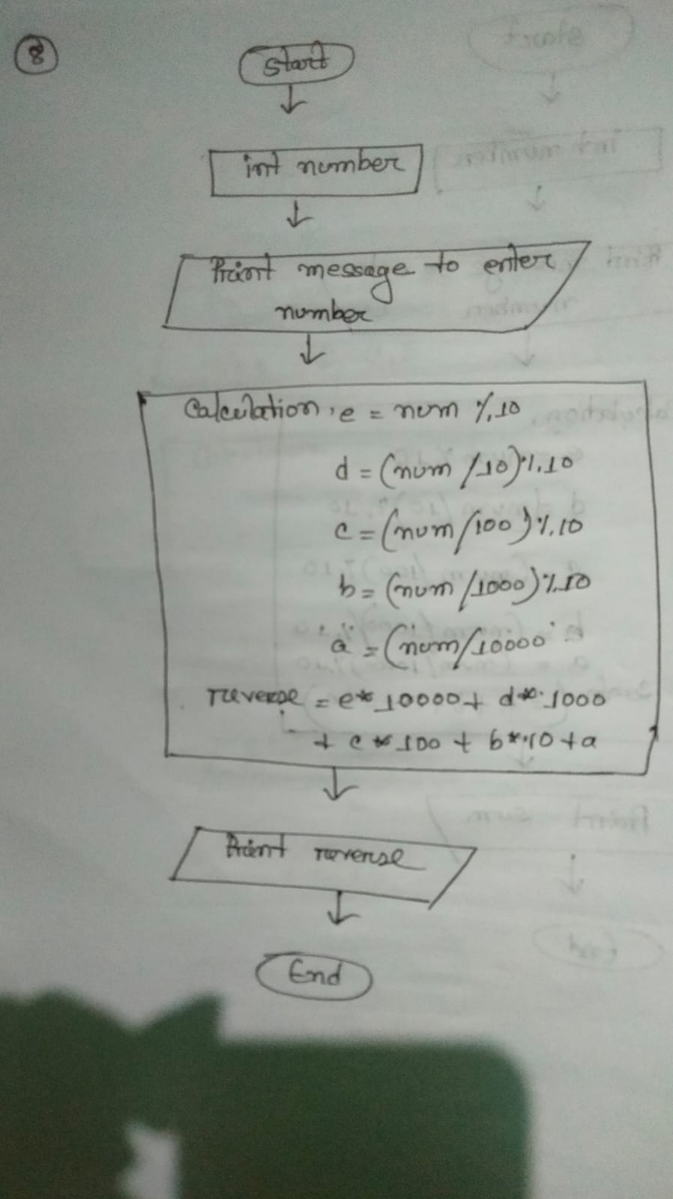 c=(num/100)%10;

b=(num/1000)%10;

a=(num/10000);

reverse = e* 10000 + d*1000 + c*100 +c*10 + d

5.Print output reverse

6.end

**9) This is c pseudocode for calculating the sum of first and last digit of any four digit number.**

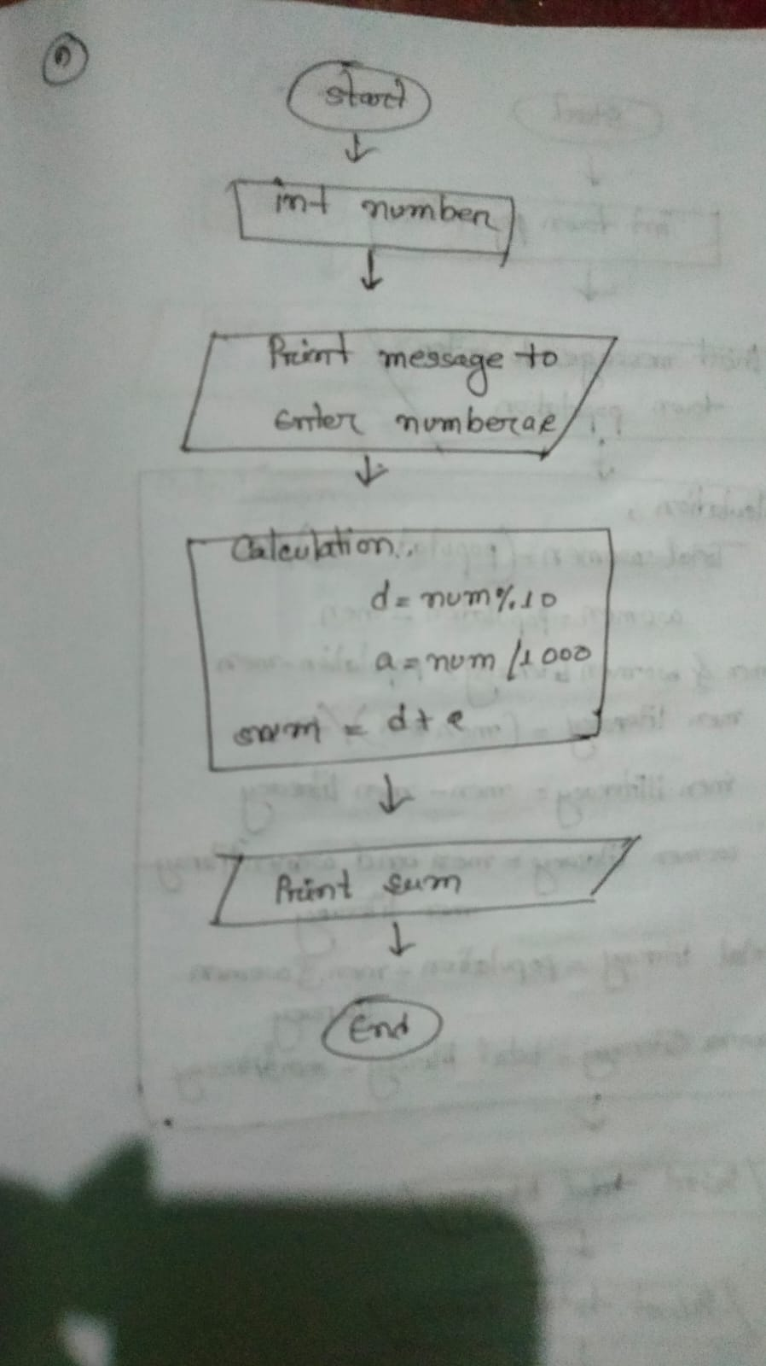1. Declare variabl (a,e) to store integer value.

2. Display the message to enter ( a,d)

3.Taking input to variable

4.Calculation, d=num%10;

a=(num/1000);

sum = a+d

5.Print output sum

6.end

**10) This is pseudo to find the total number of illiteracy men and illiteracy women if the population of the town.**

1. Declare variable (town population) to store integer value.

2. Display the message to enter ( town population )

3.Taking input to variable

4.Calculation, men=(population*52)/100;

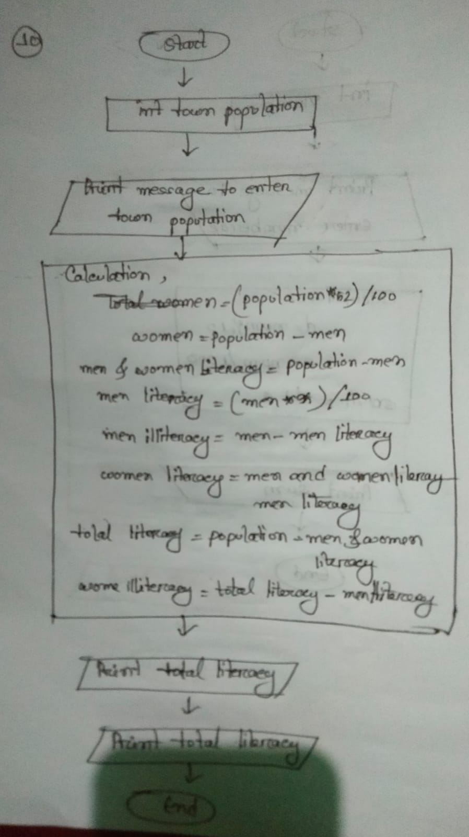 women=population-men;

men_and_women_literacy=population-men;

men_literacy=(men*35)/100;

men_illiteracy=men-men_literacy;

women_literacy=men_and_women_literacy-men_literacy;

total_literacy=population-men_and_women_literacy;

women_illiteracy= total_literacy-men_literacy;

5.Print Output total literacy

6.Print output women illiteracy

7.end

**11) this is pseudo total currency notes of each denomination the cashier will have to the with drawer.**

1. Declare variable (currency) to store integer value.

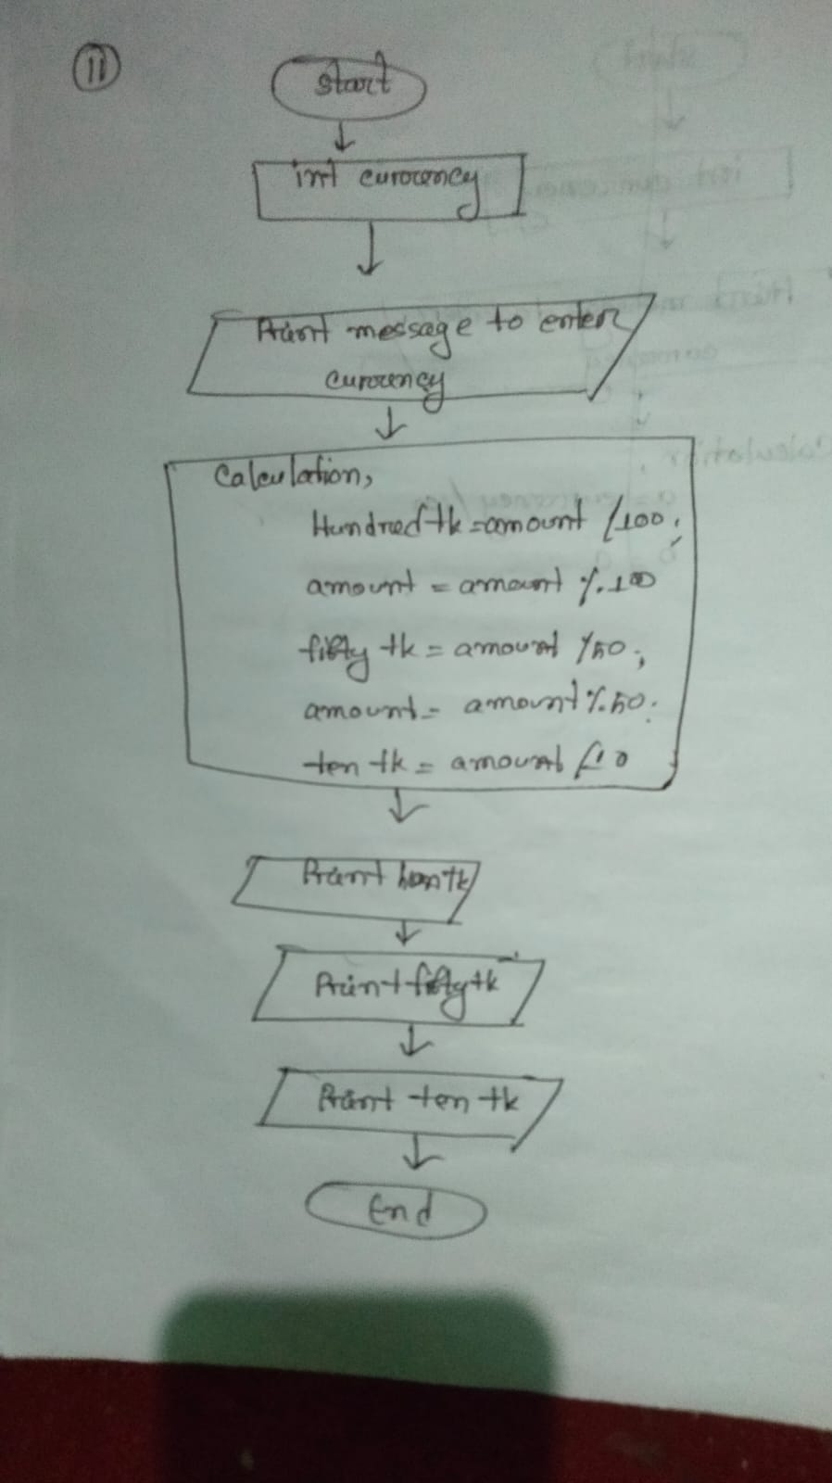2. Display message to enter ( currency)

3 3.Taking input to variable

4.Calculation,

Hundred tk=amount/100;

amount=amount%100;

fifty_tk=amount/50;

amount=amount%50;

ten_tk=amount/10;

5.Print output hun_tk

6. Print output fifty_tk

7. Print output ten_tk

8.end

**12) This pseudo codeto find the cost price of one product**

1. Declare variable (total selling prize,total profit) to store integer value.

2. Display the message to enter (total selling prize,total profit )

3.Taking input to variable (total selling prize,total profit)

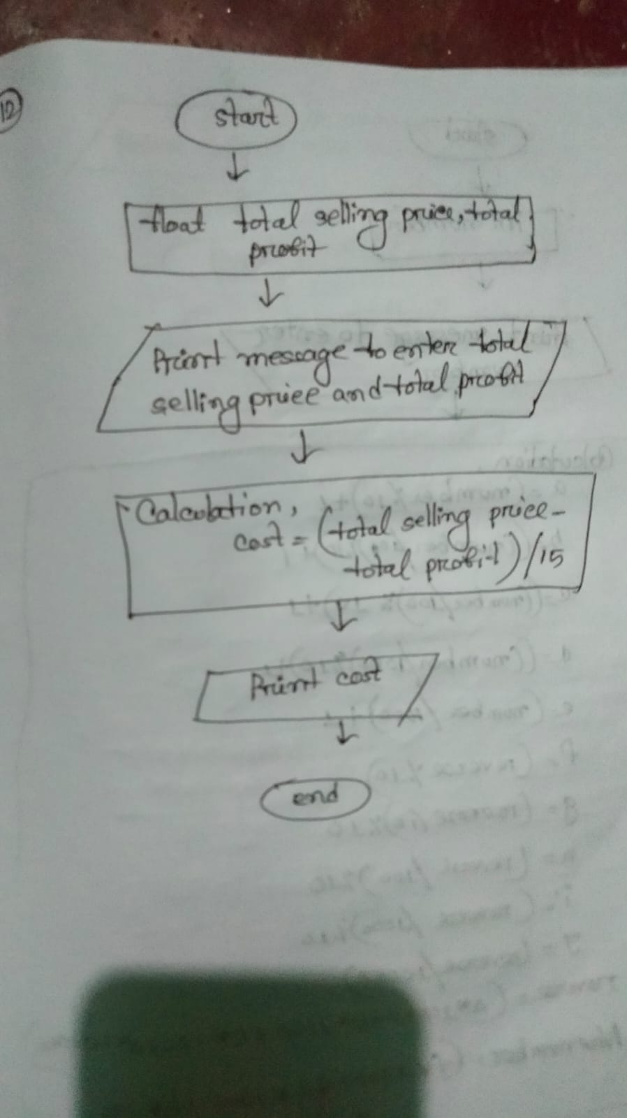4.Calculation,

one_product=(selling_price - profit_earned)/15;

5.Print output one product

6.end

**13)This is c pseudo for five digit numbers to a new number by adding one to each of its digits**

1. Declare variable (number) to store integer value.

2. Display the message to enter ( number )

3.Taking input to variable(number)

4.Calculation, a=(number%10)+1;

b =((number/10)%10)=1;

c =((number/100)%10)=1;

d=((number/1000)%10)=1;

e =((number/10000)%10)=1;

revers=(a*1000+b*1000+c*100+d*10+e*1);

f=(revers%10);

g=(revers/10)%10

h=(revers/100)%10

i=(revers/1000)%10

j=(revers/10000)%10

new number=(f*10000+g*1000+h*100+i*10+j*1

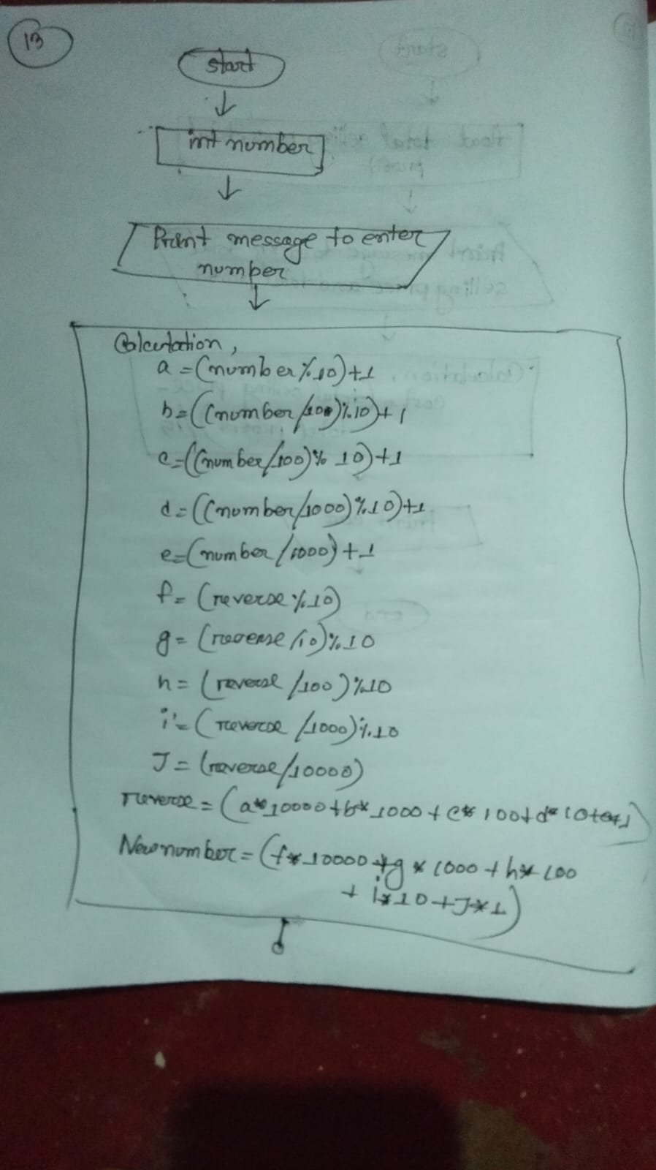5.Print output new number

6.end

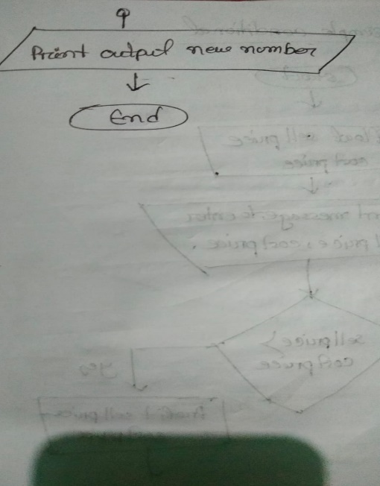

# Simple Condition or Decision making Practice

1. **This is pseudo code that determines loss or profit**

Step 1: Declare the variable (cost price, selling price) to store fractional value.

Step 2: Display the message to enter (cost price, selling price).

Step 3: Taking input to variable (cost price, selling price).

Step 4: Check

if (sell price >cost price)

Step 5: calculation,

Loss= cost price-selling price;

Profit= selling price-cost price;

Step 6: print output ("The seller has made incurred loss”)

Step 7: Otherwise, print output ("The seller has made profit”)

Step 8: End.

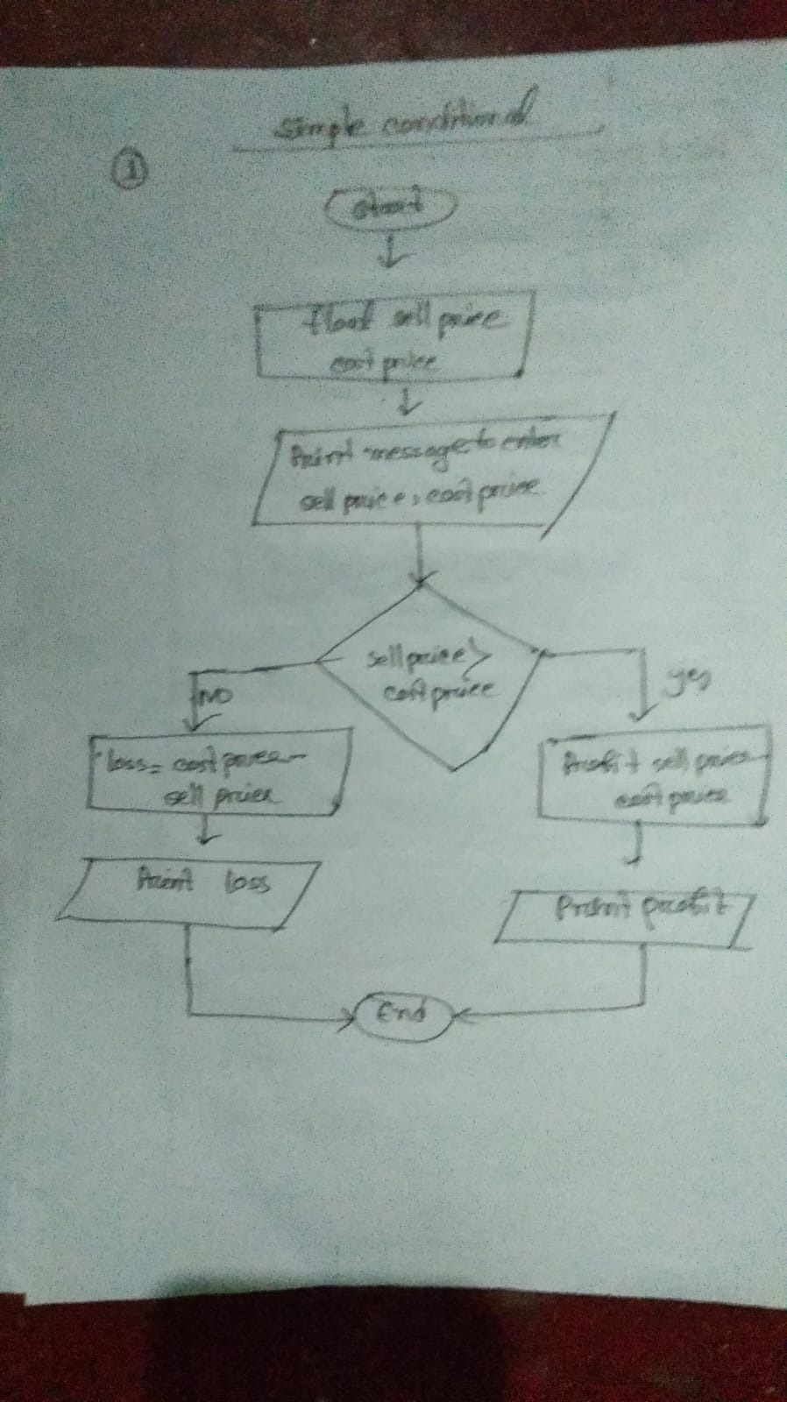

**2) This is pseudo to find out whether its an odd number and even number**

Step 1: Declare the variable (number) to store integer value.

Step 2: Display the message to enter (number).

Step 3: Taking input to variable (number).

Step 4: Check

If(number%2==0)

Step 5: Print output “The number is even”

Step 7:Otherwise,

Print output “The number is odd”

Step 8:end

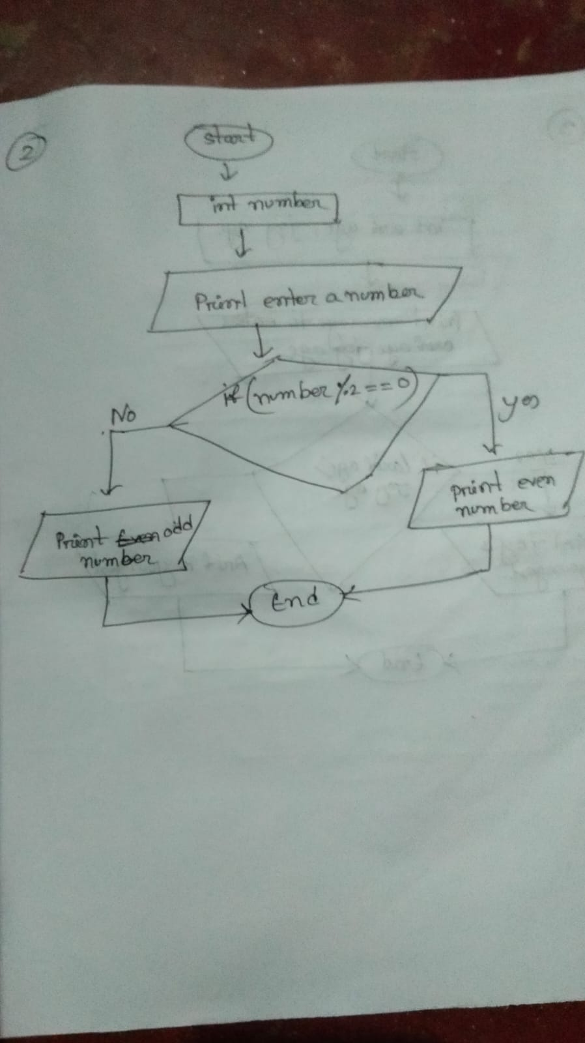

**3)This is pseudo determine the youngest one between Arif and joy**

Step 1: Declare the variable (arif age, joy age) to store integer value.

Step 2: Display the message to enter (arif age, joy age).

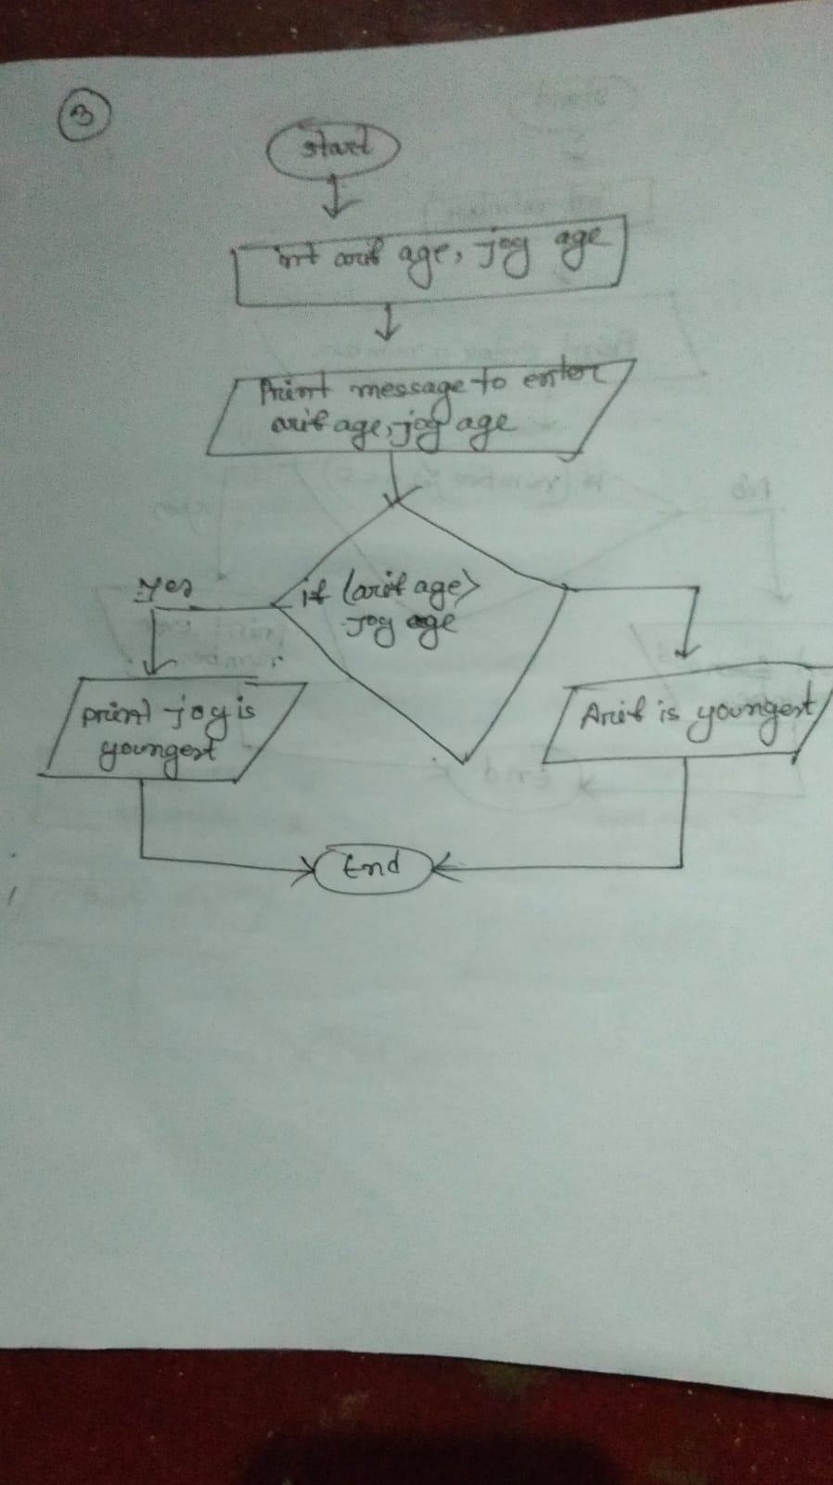 Step 3: Taking input to variable (arif age, joy age).

Step 4: Check

If(arif age>joy age)

Step 5: Print output “Arif is the youngest”

Step 7:Otherwise,

Print output “joy is the youngest”

Step 8:end



**4) This is c pseudo can check whether a triangle is valid or not**

Step 1: Declare the variable (angle_1,angle_2,angle_3) to store integer value.

Step 2: Display the message to enter (angle_1,angle_2,angle_3).

Step 3: Taking input to variable (angle_1,angle_2,angle_3).

Step 4: Check

If(angle_1+angle_1+angle_1==180)

Step 5: Print output “The triangle is vaild ”

Step 6:Otherwise,

Print output “The triangle is not vaild”

Step 7:end

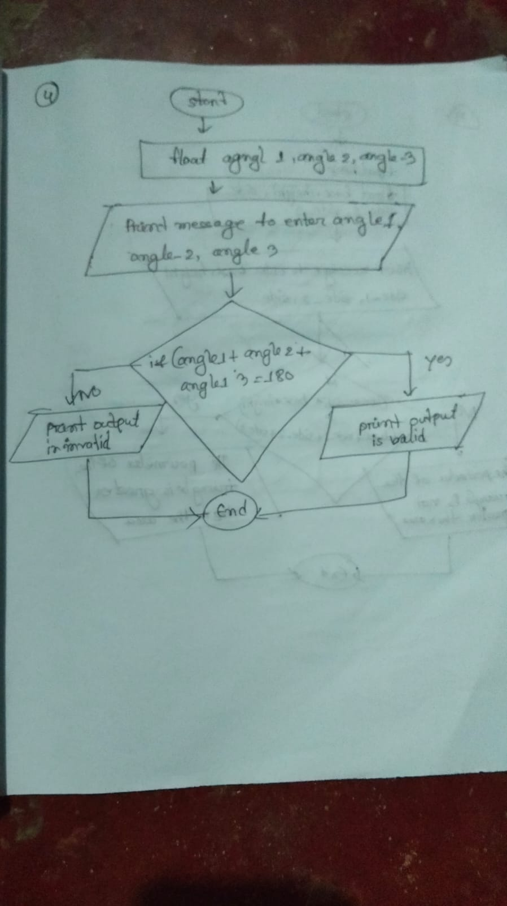

**5) This is c pseudo can Check if the area of triangle is greater than the perimeter of the triangle**

Step 1: Declare the variable (base, height,side_1,side_2,side_3) to store fractional value.

Step 2: Display the message to enter (base, height,side_1,side_2,side_3).

Step 3: Taking input to variable (base, height,side_1,side_2,side_3).

Step 4: Check

If((0.5*base*height)>(base+side_1+side_2+side_3))

Step 5: Print output “The area of triangle is greater than the perimeter of the triangle"

Step 6:Otherwise,

Print output “The area of triangle is not greater than the perimeter of the triangle"

Step 7:end

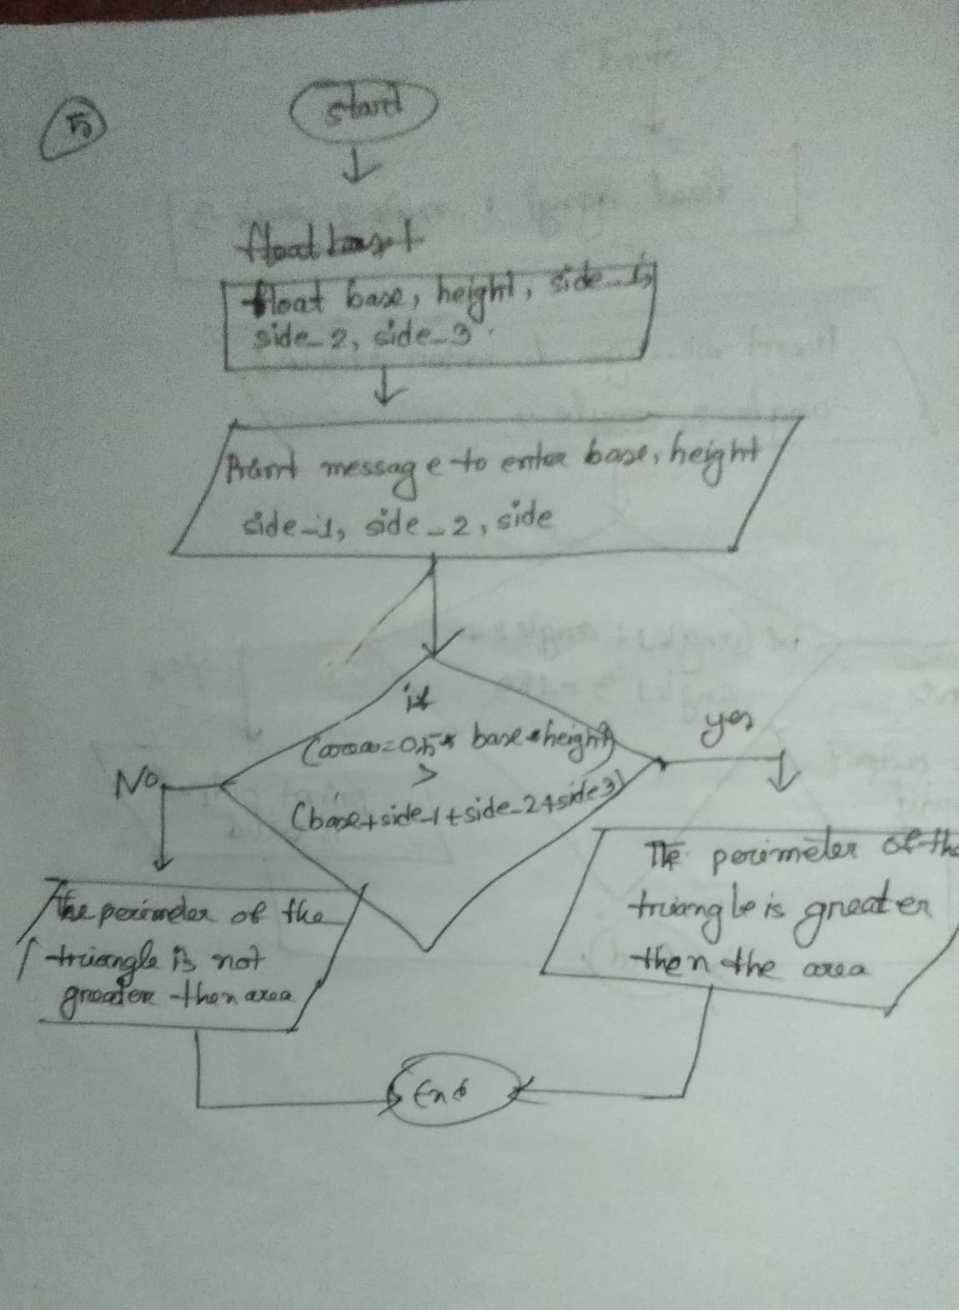

**6) This program pseudocode determines whether a number is positive or not**

Step 1: Declare the variable (number) to store fractional value.

Step 2: Display the message to enter (number).

Step 3: Taking input to variable (number).

Step 4: Check

If(num>0)

Step 5: Print output “This number is positive”

Step 6: Otherwise,

Print output “This number is not positive”

Step 7: end

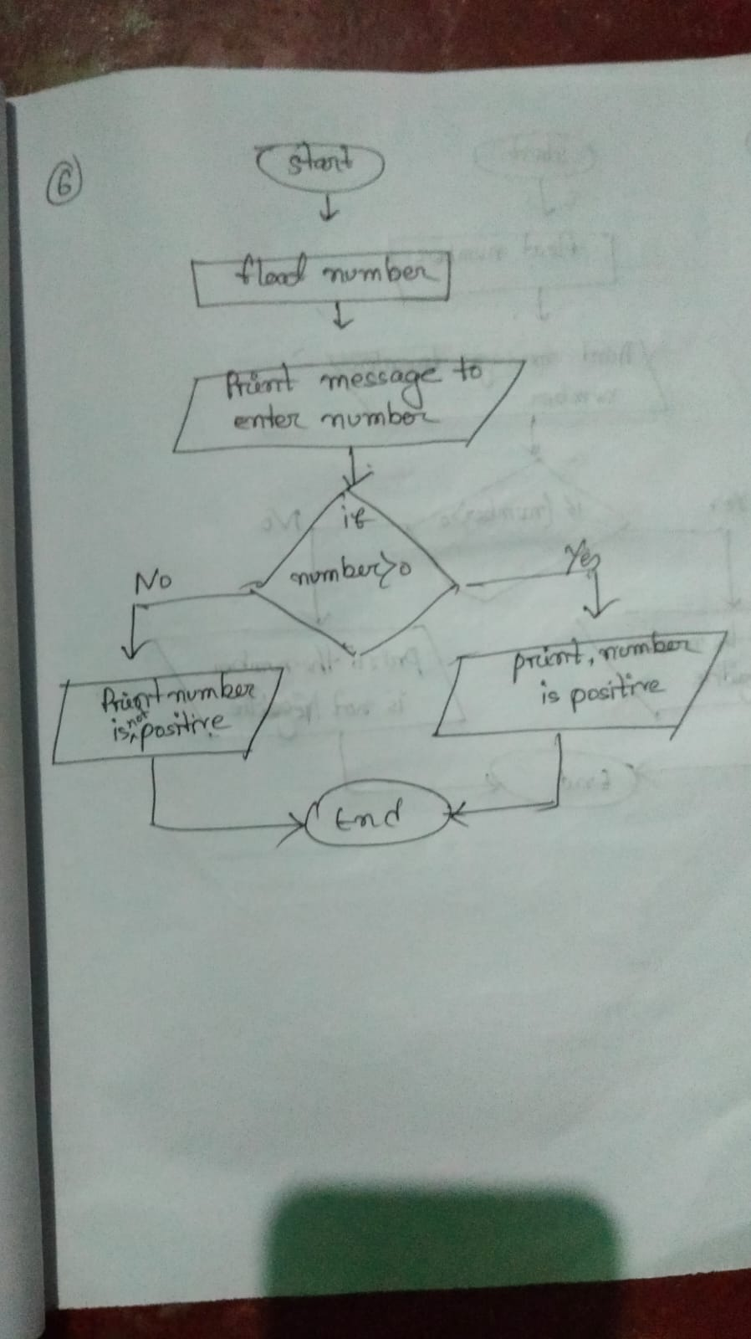

**7) This program pseudocodedetermines whether a number is negative or not**

Step 1: Declare the variable (number) to store fractional value.

Step 2: Display the message to enter (number).

Step 3: Taking input to variable (number).

Step 4: Check

If(num<0)

Step 5: Print output “This number is negative ”

Step 6:Otherwise,

Print output “This number is not negative”

Step 7:end

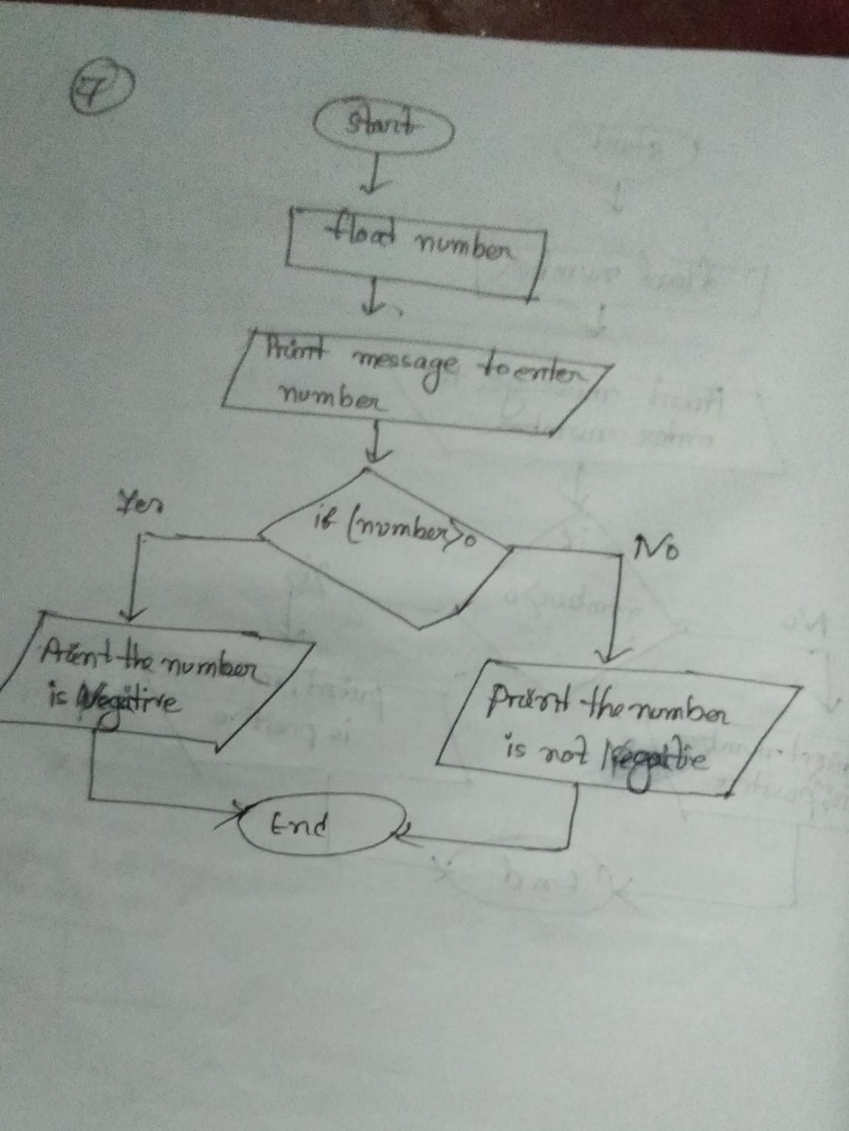

**8) This program pseudo determines whether a number is zero or not**

Step 1: Declare the variable (number) to store fractional value.

Step 2: Display the message to enter (number).

Step 3: Taking input to variable (number).

Step 4: Check

If(num==0)

Step 5: Print output “This number is zero ”

Step 6:Otherwise,

Print output “This number is not zero”

Step 7:end

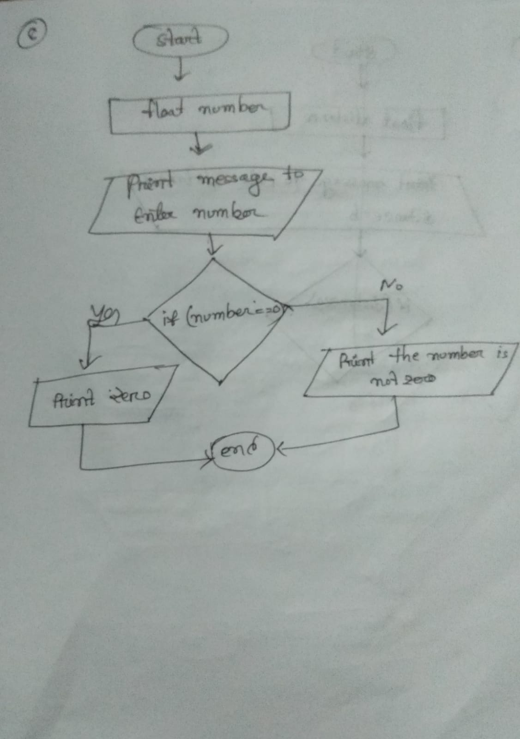

**9)This is the program for determining the shortest route**

Step 1: Declare the variable (a,b,,,Distance) to store fractional value.

Step 2: Display the message to enter (a,b).

Step 3: Taking input to variable (a,b).

Step 4: Check

If(a<b)

Step 5: Print output “A is the shortest route to the destination ”

Step 6:Otherwise,

Print output “B is the shortest route to the destination”

Step 7:end

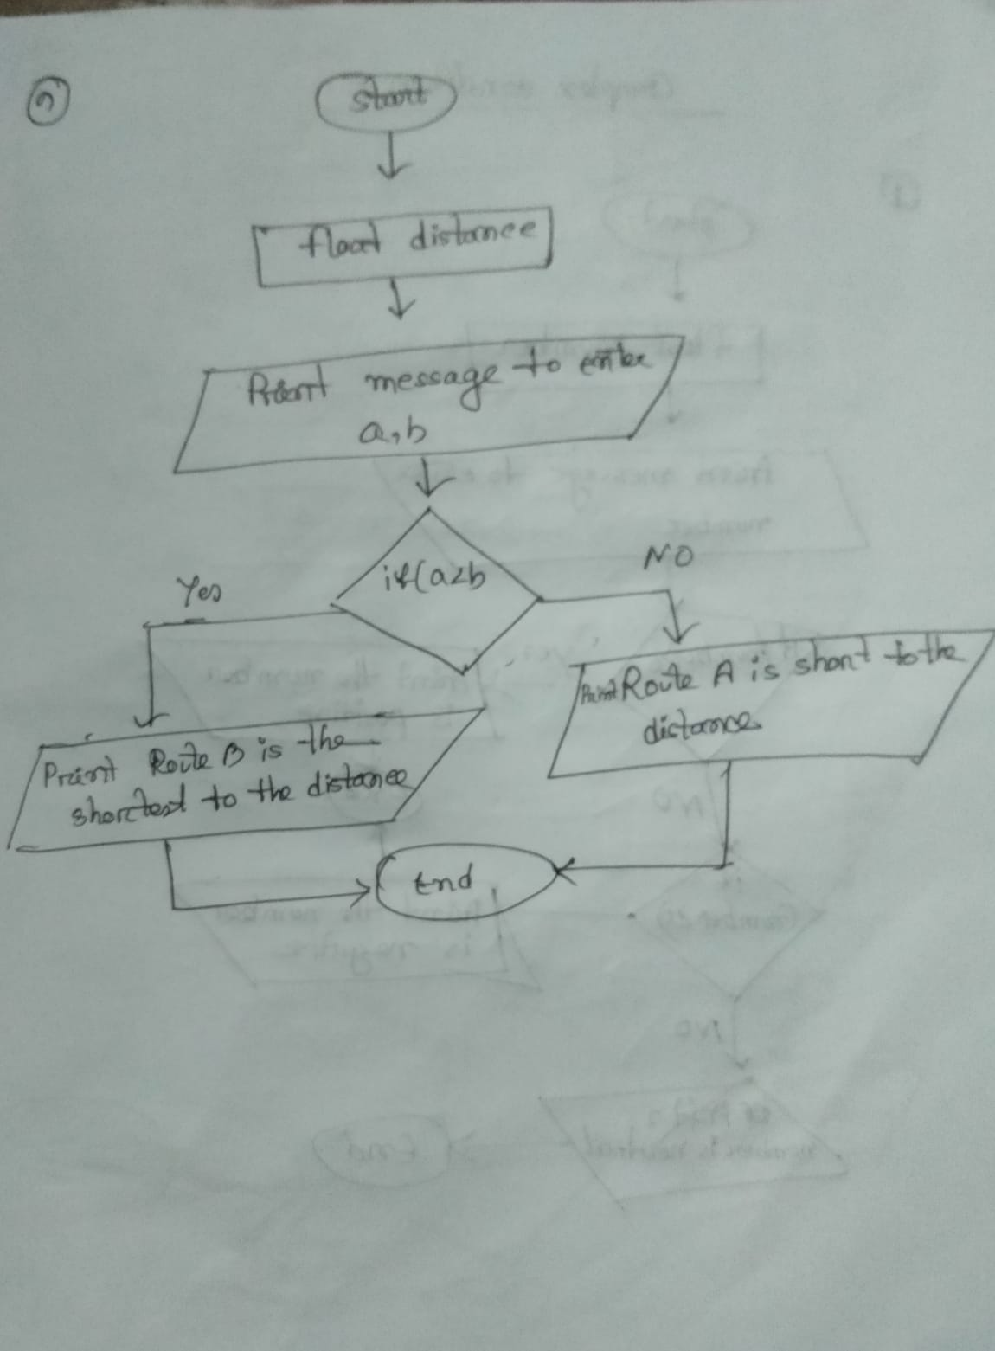

# Complex Condition Decision Making Practice

**1) This is c program pesudo that can take input a number and then decide whether the number is positive ,negative or neutral**

Step 1: Declare the variable (number) to store integer value.

Step 2: Display the message to enter (number).

Step 3: Taking input to variable (number).

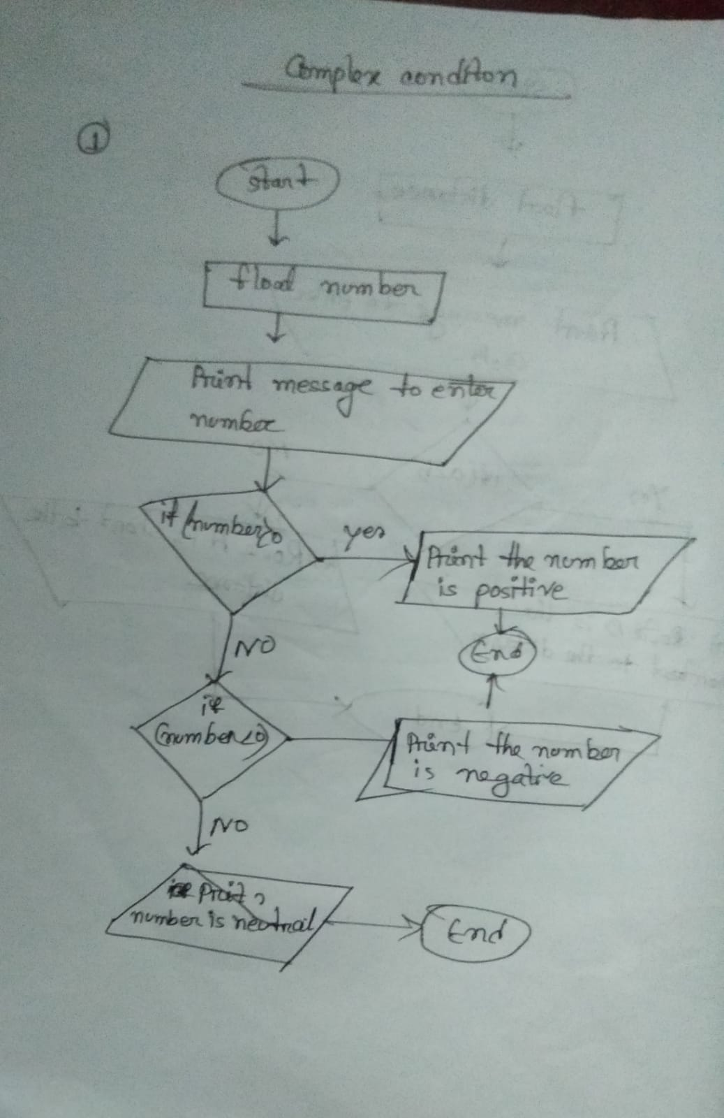 Step 4: Check

If(num>0)

Step 5: Print output “This number is positive ”

Step 6:Otherwise,

Print output “This number is negative”

Step 7:Otherwise,

Print output “This number is neutral”

end



**2) This is c program pesudo to display a menu in a restaurant and user choice**

Step 1: Declare the variable (choice) to store integer value.

Step 2: Display the message to enter (1.rice 2.Fish 3.Chicken 4.vegetable ).

Step 3: Taking input to variable (choice).

Step 4: Check

If(choice==1)

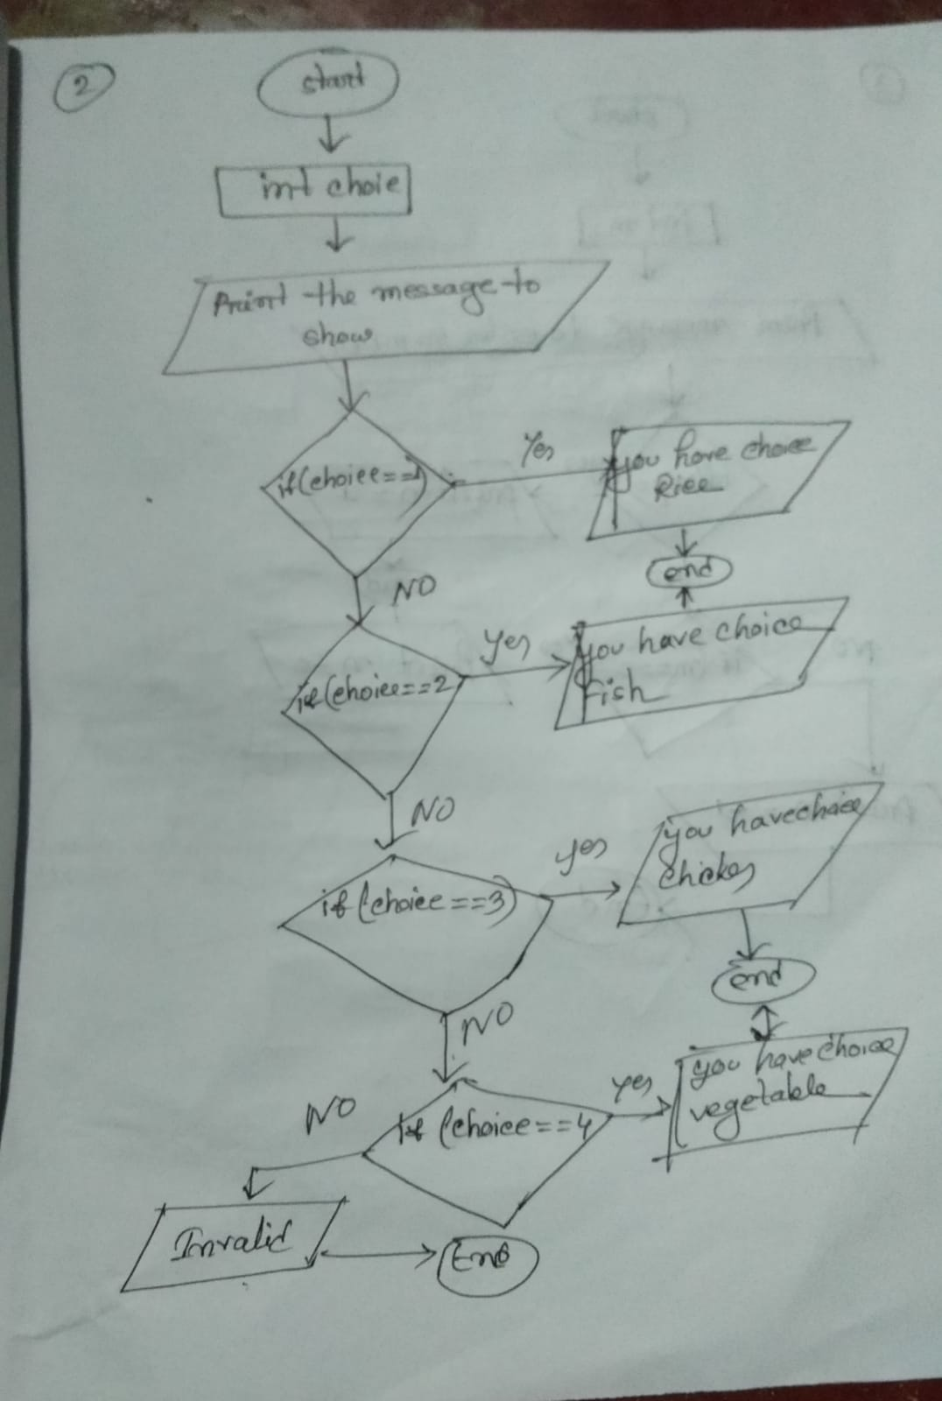Step 5: Print output “your food menu is rice”

Step 6:Otherwise,

If(choice==2)

Step 7:Print output “your food menu is fish”

Step 8:Otherwise,

If(choice==3)

Step 9:Print output “your food menu is Chicken”

Step 10:Otherwise,

If(choice==4)

Step 11:Print output “your food menu is vegetable”

Step 13:Otherwise,

Step 14:Print output “your food menu is not available”

Step 8:end

**3)This c program pseudocode reads the value of an integer m and display the value of m is 1 when m is larger then 0,0 when m is 0 and and -1 when m is less than 0.**

Step 1: Declare the variable (m) to store integer value.

Step 2: Display the message to enter (number).

Step 3: Taking input to variable (m).

Step 4: Check

If(m>0)

Step 5: Print output “This number is 1 ”

Step 6:Otherwise,

else if(m==0)

Print output “This number is 0”

Step 7:Otherwise,

Print output “This number is -1”

Step 8:end

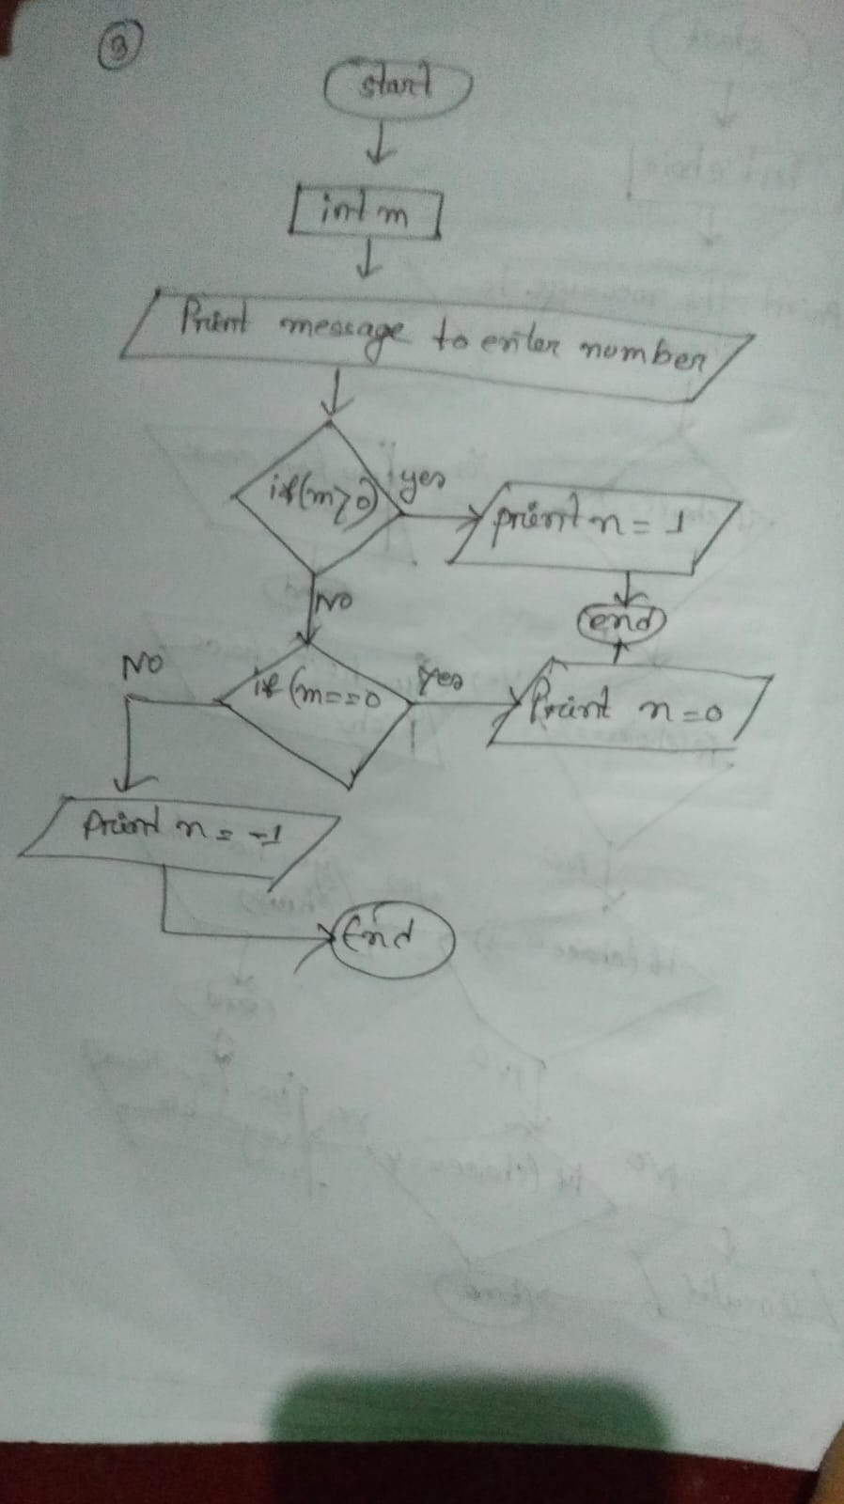

**4) This c program pseudo to input week number and print week day**

Step 1: Declare the variable (week) to store integer value.

Step 2: Display the message to enter (week number).

Step 3: Taking input to variable (week).

Step 4: Check

If(week>=1 && week<=52);

Step 5: Print output “Saturday, Sunday,Monday, Tuesday,Wednusday, Thrusday, Friday";

Step 6:Otherwise,

Print output “ Invalide”

Step 8:end

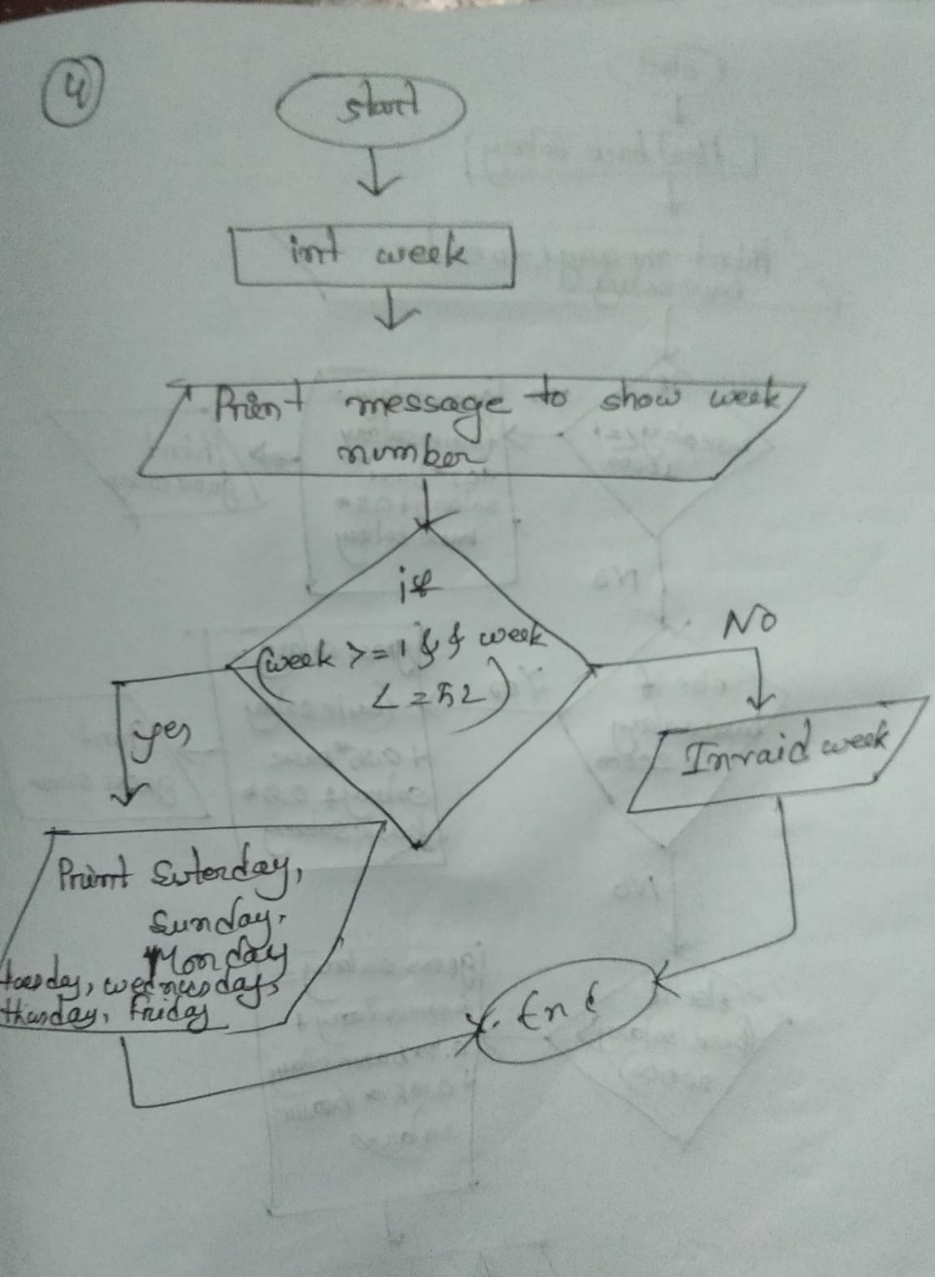

**5) This program pseudo code takes basic salary of an employee and calculate its Gross salary according to following:**

basic salary<=10000 : HRA = 20% ,DA =80%

basic salary<=20000 : HRA = 25% ,DA =90%

basic salary>20000 : HRA = 30% ,DA =95%

Step 1: Declare the variable (basic salary) to store fractional value.

Step 2: Display the message to enter (basic salary).

Step 3: Taking input to variable (basic salary).

Step 4: Check

If(basic salary <=10000)

Step 5: Print output,

your gross salary is =basic_salary+0.2*basic_salary+0.8*basic_salary

Step 6:Otherwise,

else if “basic salary<=20000”

Step 7:Print output ,

your gross salary is =basic_salary+0.25*basic_salary+0.9*basic_salary”

Step 8 : Otherwise,

else if ( basic salary>20000)

Step 9: Print output ,

“your gross salary is =basic_salary+0.3*basic_salary+0.95*basic_salary”

Step 10 :end

